
GUIDANCE NOTES FOR PARENTS / CARERS REQUESTING
A LEAVE OF ABSENCE DURING TERM TIME

Parents / carers wishing the school to consider granting leave in term time should read these notes carefully and then complete and send the request form below to the School Office who will pass it to the Headteacher.

The form must be sent in time for the request to be considered before the desired period of absence. Parents / carers are strongly advised not to finalise any planned absence before receiving the school’s decision regarding the request. In any event, the request form must be received by the school at least four school weeks before the leave in term time requested dates to allow sufficient time for appropriate consideration, unless the reason for absence could not reasonably have been anticipated (for example, in the case of a funeral).

Each case will be considered individually and on its own merits. Parents and carers need to consider very carefully before making any request for leave in term time, the demands of the National and wider school curriculum, especially at the Key Stage assessment stage. In considering a request, the school may also
take account of:
- the exceptional circumstances stated that have given rise to the request
- whether the child is of compulsory school age
- the stage of the child’s education and progress and the effects of the requested absence on both
- elements
- whether the same trip could be taken during the 13 weeks school is closed to pupils
- the nature of the absence
- whether pupils are due to participate in statutory assessments during the period of requested absence

Farndon Fields Primary School cannot authorise holidays during term time. While the school cannot authorise term time leave other than in exceptional circumstances, it is important that families complete a leave of absence form and are open and honest about their child(ren)’s whereabouts to avoid safeguarding concerns arising. If the school has reason to believe that an absence reported is due to a holiday rather than the reason reported, it will be marked as unauthorised.

Parents / Carers should be aware that the law enforces the position regarding holidays. The Education (Pupil Registration) (England) (Amendment) Regulations 2013, which become law on 1st September 2013, state that the Headteacher may not grant any leave of absence during term time unless there are exceptional circumstances. A family holiday during term time does not fall under the category of ‘exceptional circumstances’. As set out in the school's Attendance Policy, and in line with the DfE statutory guidance document Working together to improve school attendance (2024), when the threshold of 5 days / 10 sessions of unauthorised absence in a rolling 10-week period has been reached, especially in relation to term-time holidays, a referral will be made to the Local Authority for the issuing of a penalty notice.

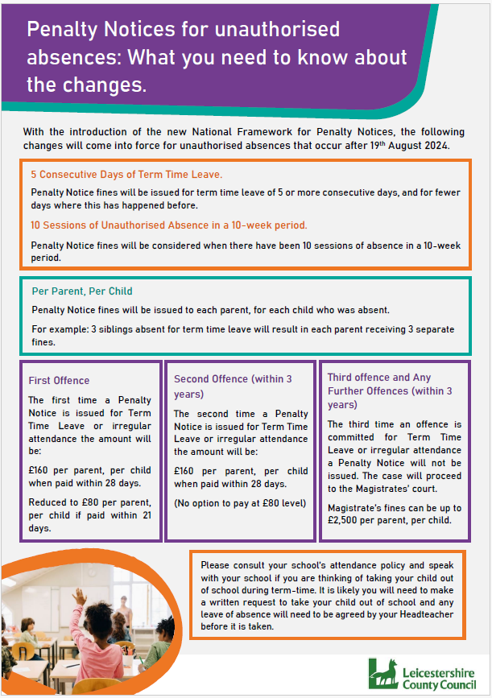


Request for Leave of Absence in Term time

I am requesting leaving term time for my child(ren):

Name: ______________________________________________________________ Class: _____________

Name: ______________________________________________________________ Class: _____________

Name: ______________________________________________________________ Class: _____________

From (date): _________________to (date) _________________ for (number) ________ school days

My child(ren) will be accompanied during the period of leave by:

Name of adult(s): ________________________________Relationship to child(ren):__________________

Alternative Emergency contact (UK) during period of absence:

Name & contact no: ______________________________Relationship to child(ren):__________________

The exceptional circumstances / reason for this request are:

If necessary, please continue on a separate sheet and attach with this form
I have attached additional evidence with this request: oYes oNo
Name of 1st parent / carer ____________________________________Signed:_______________________

Current address: ___________________________ ______________

Mobile no:_____________________

If applicable:
Name of 2nd parent /carer ___________________________________Signed: _______________________

Current address: ___________________________ ______________

Mobile no:_____________________

FOR OFFICE USE ONLY
Date request received by school: _____________________________

Current attendance: ______________ %

Last Year’s attendance: ______________ %

Number of days taken in the last 12 months: _________

Number of days taken in the last 3 years: _________

Leave in term is agreed / not agreed for the above pupils.

Number of days authorised: _________ Number of days unauthorised: _________

Notification of decision sent to parent(s) / carer(s):____________________________

Signed: ______________________ Name: _______________________________ Date: ___ __________

